Problem Based Learning(PBL)

Objective
Create a secure web-based Product Management System that uses prepared statements to prevent SQL injection attacks.

Task : Create Secure Form Handler (formsubmit.php)
Create a PHP script to handle form submission with SQL injection prevention:
Requirements:
- Retrieve POST data from the form
- Connect to MySQL database
- Use prepared statements to prevent SQL injection
- Insert data into the product table
- Redirect to display page after successful insertion
CODE:
<!DOCTYPE html>
<html lang="en">
<head>
<meta charset="UTF-8">
<meta name="viewport" content="width=device-width, initial-scale=1.0">
<title>Document</title>
<link rel="stylesheet" href="bootstrap/css/bootstrap.min.css">
<script src="bootstrap/js/bootstrap.bundle.min.js"></script>
</head>
<body>

<div class="container ">
<div class="row">
<div class="col-6">
<div class="card d-flex justify-content-start">
<div class="card-body">
<h1>product form</h1>
<form action="formsubmit.php" method="post">
<div class="form-group">
<label>product name</label>

<input type="text" name="product_name" id="product_name" class="form-control" >
</div>
<div class="form-group">
<label>product category</label>

<input type="text" name="product_category" id="product_category" class="form-control" >
</div>
<div class="form-group">
<label>product quantity</label>

<input type="number" name="product_quantity" id="product_quantity" class="form-control" >
</div>
<div class="form-group">
<label>product price</label>

<input type="text" name="product_price" id="product_price" class="form-control" >
</div>
<div class="d-flex justify-content-center">
<input type="submit" class="btn btn-primary " value="submit">
</div>
</form>
</div>
</div>
</div>
</div>
</div>
</body>
</html>
<?php
$product_name = $_POST['product_name'];
$product_category = $_POST['product_category'];
$product_quantity = $_POST['product_quantity'];
$product_price = $_POST['product_price'];

$connection = mysqli_connect('localhost', 'root', '', 'products');
$query = "INSERT INTO product(product_name,product_category,product_quantity,product_price)
values(?,?,?,?)";
$stmt = mysqli_prepare($connection, $query);
mysqli_stmt_bind_param($stmt, 'ssid', $product_name, $product_category, $product_quantity, $product_price);#tightly coupled khelata jo s or i use kea hai k ye data arha hai
mysqli_stmt_execute($stmt);
header('Location: ' . 'tableshow.php');

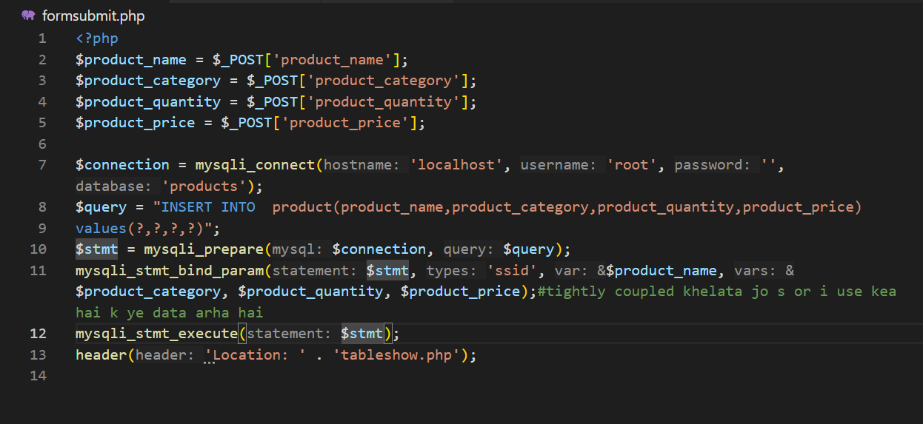
SCREENSHOT:
